Collateral Web

TFS 92351 – Enhance scenarios for object ownership;

TFS 92357 – Multiple Collateral Scenarios

Feature Overview

Modify the process by which scenarios are created and modified to include various scopes. This is to help draw awareness to existing scenarios that already include a certain scope and hopefully minimize, if not completely eliminate, the need for data cleanups.

# Document Change History

|  |  |  |  |  |
| --- | --- | --- | --- | --- |
| Version | Date Changed | Description | Approved By | Date Approved |
| 1 | 08/26/16 | Document started | Rebeca McFarland | 08/26/16 |
| 2 | 09/08/16 | Updated mock-ups and other edits | Bevin Morrissey | 09/08/16 |
| 3 | 09/22/16 | Design regroup | Bevin Morrissey | 09/23/16 |
| 4 | 12/30/2016 | Document updated with new FPI Recommended solution – DOCUMENT IS UNFINISHED, contains notes and suggestions for future review | Bevin Morrissey & Rebecca McFarland | 12/30/2016 |

FPI Credit Products

December 30, 2016

Table of Contents

Collateral Web 1

Document Change History 1

Statement of the Problem 2

FPI RECOMMENDATION 3

TFS 92351 – Enhance scenarios for object ownership; TFS 92357 – Multiple Collateral Scenarios

## Statement of the Problem

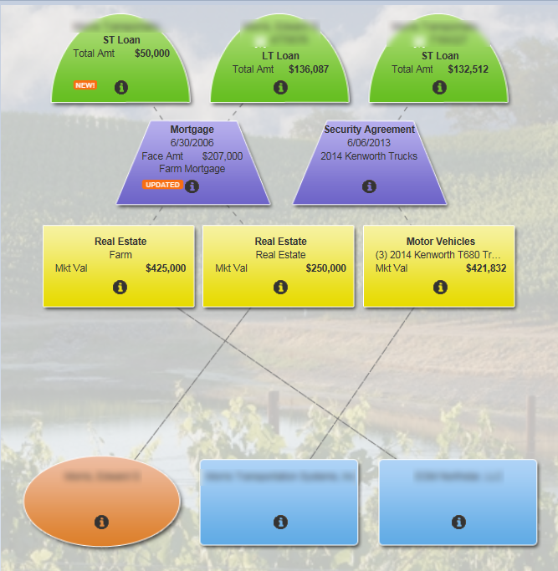

**Sue** is working on the **short term loan** on the right side of the picture in an existing scenario.

**Dave** is working on the **short and long term loans** on the left side of the picture.

If one of these two employees updates collateral belonging to a loan in the same scope, the two scenarios become entangled and FPI has to manually clean up data in the database with a script.

We would like to make it more obvious which collateral objects belong to which scope, and make it more difficult to lock up scenarios by creating multiple scenarios that include the same scope.

**Multiple Scenarios** – there are actually THREE different problems here that we are going to analyze:

1.       Collateral Web does not notify you soon enough during the Submit process that your changes will impact another existing scenario and that you cannot continue

2.       While you are working in one scenario, Collateral Web does not currently alert you when you have started updating a scope that is part of another existing scenario

3.       Would like to be able to set a configurable limit on the number of scenarios per scope (Eastern ACA’s only)

## FPI RECOMMENDATION

Scope Exists in Another Scenario Alert

If a scenario already exists and **Dave** edits a scope that is already included in the existing scenario, the following alert appears:

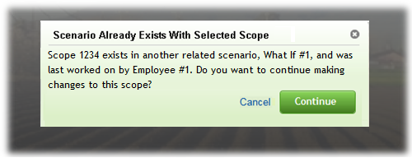

Text on this alert should be:

“The object you have just modified is already part of the following scenarios:

What If #1 – Last Touched by Rebecca McFarland

What If #2 – Last Touched By Bevin Morrissey

Do you want to continue?”

Dave can choose to:

* **“Cancel”** to undo changes and return to current scenario
* **“Continue”** to EITHER add this scope to the current scenario, OR, if alert appeared from Current Production, create a new scenario

The alert will notify Dave **who** is working on that scope and **which scope(s)** will be affected.

These alerts will only appear the first time that the scope is edited. After the scope has been added to the current scenario, Dave can edit anything in that scope and will not receive any additional alerts. However, if Dave edits a different scope that is not yet part of the current scenario, this alert will fire again, IF that scope already is included in another existing scenario.

NOTE: See problem #3 defined above…if adding a configuration to limit the number of scenarios allowed per scope (ACA level parameter), then you will not be allowed to continue making changes to that scope as part of your current scenario.

Validating a Scenario

If Dave attempts to **validate** a scenario that includes a scope that Sue has made changes to, Dave will receive an alert.

**“Your scenario includes changes that impact another existing scenario. If you submit <Current Scenario Name>, the following Scenario(s) will be cancelled: Scenario 1234. (Sue Software)”**

Scope(s) Will Be Cancelled Upon Submission

If Dave attempts to **submit** a scenario that includes a scope that Sue has made changes to, Dave will receive the alert:

**“During the submit process, the following Scenario(s) will be cancelled: Scenario 1234. (Sue Software)”**

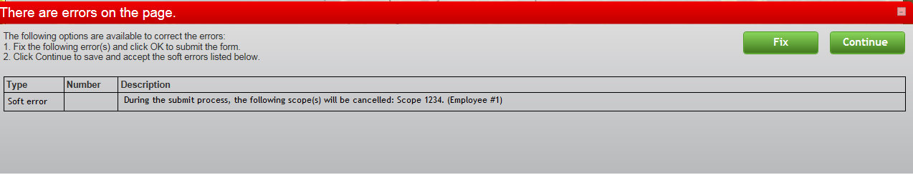

Dave can choose to:

* **“Fix”** and **not** **submit** the scenario
* **“Continue”** to **submit** the scenario

If the scenario is **submitted**, Sue Software receives the alert:

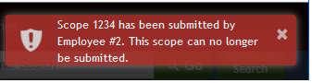

NEED TO TEST TO SEE HOW THIS WORKS TODAY. If Dave submits his scenario while Sue is in CW and working on her scenario, does Sue get any alert?

This alert will prevent Sue from being unaware that the work she is doing can not be submitted.

Currently, Sue would have her entire scenario deleted. She would have to start over from Current Production.

Undo/Redo Changes

If Dave chooses not to submit the scenario and selects **“Fix”**, we propose adding the ability to “**Undo Changes”** for the entire scope that was affected.

This change would give Dave the opportunity to ensure that Sue does not lose any work.

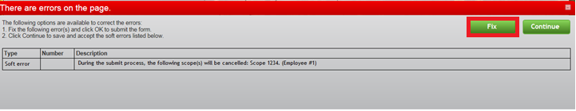

Add option called: “Identify Conflicting Objects”

This option would highlight objects that have conflicting changes across scenarios with a RED OUTLINE.

There needs to be some way to turn off the red outline….

If want to remove the changes made on an object that has conflicting updates in two different scenarios, then use object menu and select a new option called “Undo Changes”, which reverts object information back to equivalent of Current Production.

